Signing in to Check-in Attendees: Phone
- Go to Eventbrite.com on your laptop or go to #2.
- Download Eventbrite Organizer App (*Not the same as the Eventbrite User App, see difference below in phone screenshot.)
- Log-in with your Username and Password (See Email List to Verify your Email Address has access to 2022 ProductCamp Event)
- Select correct year for ProductCamp.
- Choose “Check-In” at the bottom of the screen.
- Search for Attendees at the top right or press orange button to scan their ticket.
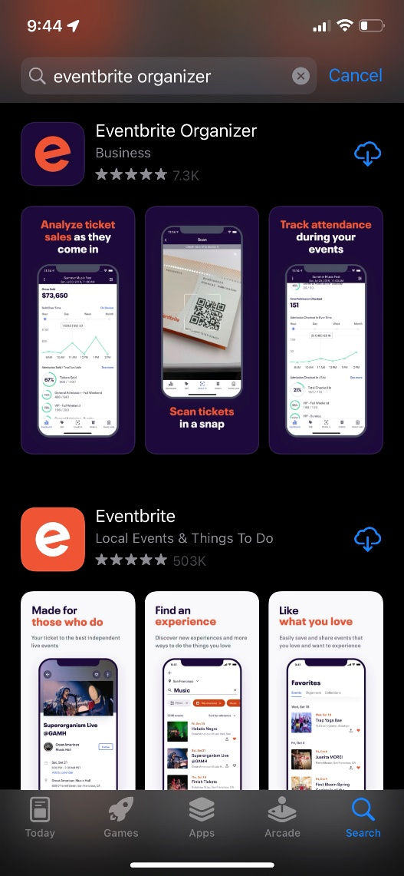

Signing in to Check In Attendees: Laptop
- Go to Eventbrite.com on your laptop.
- Log-in with your Username and Password. (See Email List to Verify your Email Address has access to 2022 ProductCamp Event).
- Click drop down in right hand corner.
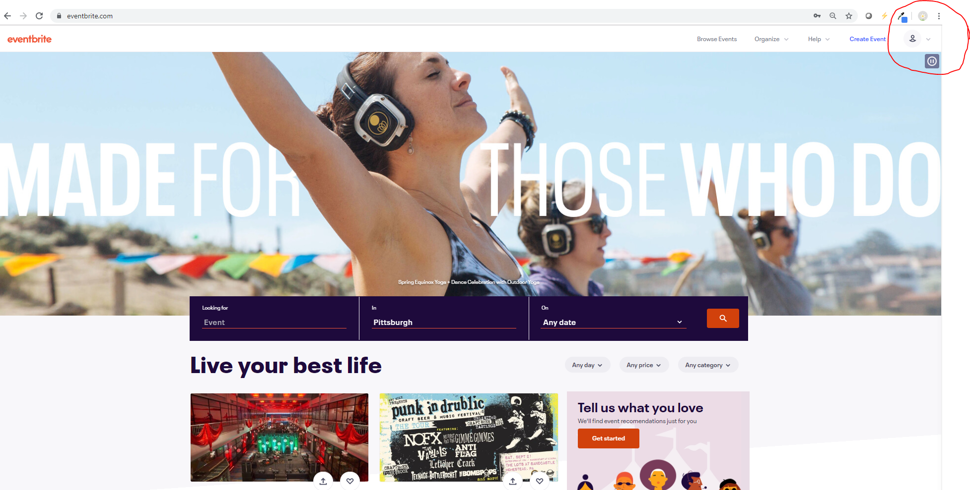
- Hit “Manage Events”
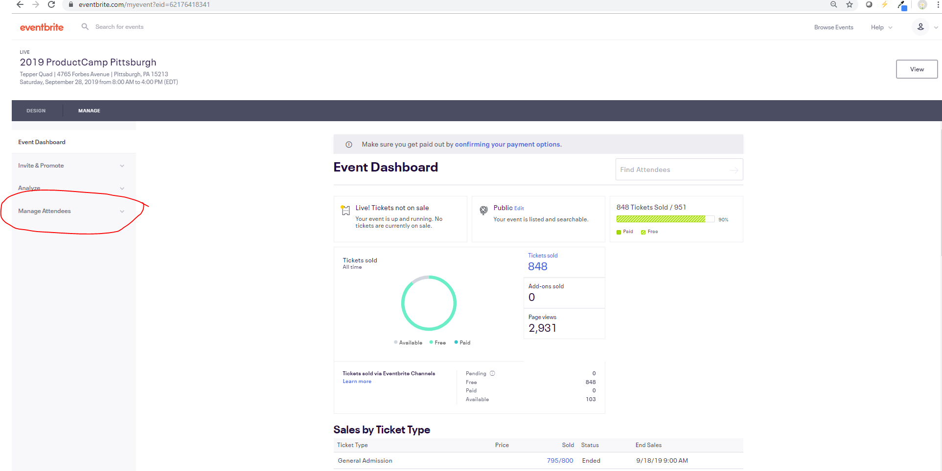
- Select appropriate ProductCamp Event for the year.
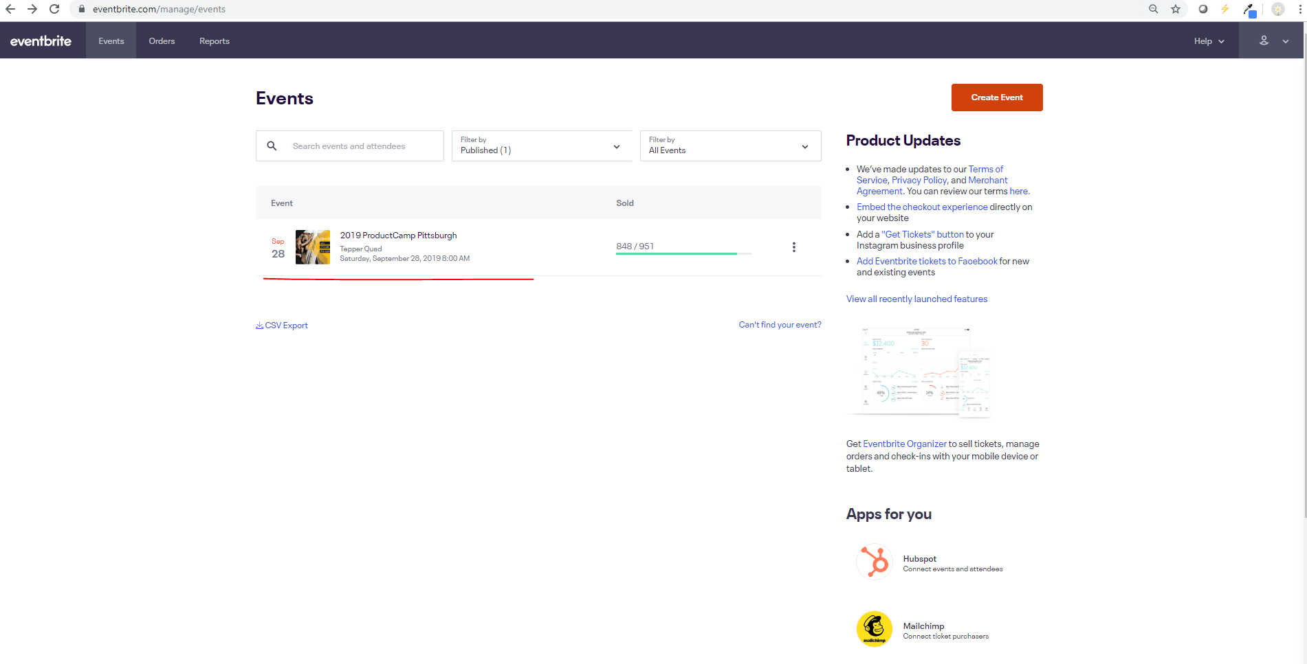
- Hit “Manage Attendees” drop down in the left side of EventBrite menu & select “Check-in.”
- Check-in Attendees by searching for their last name or email.
- Hit “Check-In” in the STATUS column once you’ve found the correct attendee.
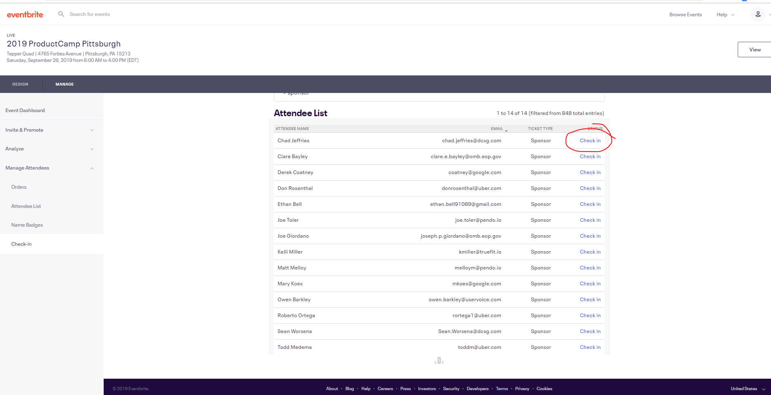

If your name is on the list please use your account with the Eventbrite Organizer app or check-in.
All Event Organizers on bi-weekly calls have been added.
First Name | Last Name | Email
Brad | Eiben | beiben@andrew.cmu.edu
Andreas | Maihoefer | amaihoefer@ensoconsultingllc.com
Dan | Russell | danrussell1117@gmail.com
Corey | Grone | corey@coreygrone.com
Yan | Zhao | yzhao1@hotmail.com
Mark | Adkins | mark.adkins@leanmedinnovation.com
Lisa | Carter | lccarter315@gmail.com
Yueer | Tang | yueert@andrew.cmu.edu
Jennifer | Sydeski | jennifersydeski@gmail.com
Kevin | Voller | krvoller@gmail.com
Aniket | Gupta | 2022aniketgupta@gmail.com
Sudhir | Gupta | sudhirnagendragupta@gmail.com
Aman | Sachan | asachan@andrew.cmu.edu
Kshitij (KP) | Pandya | kapandya@tepper.cmu.edu
Vidhika | Lonare | vlonare@andrew.cmu.edu
Anchal | Chaudhary | anchalc@andrew.cmu.edu
Email Address

Email Address
pghpcamp@gmail.com (administrator)
Email Address  karingregory@gmail.com |  |  | Top of Form  EDIT | DELETE  Bottom of Form
Email Address  megreen18@gmail.com |  |  | Top of Form  EDIT | DELETE  Bottom of Form
Email Address  jim@jimberardone.com |  |  | Top of Form  EDIT | DELETE  Bottom of Form
Email Address  abilak@andrew.cmu.edu |  |  | Top of Form  EDIT | DELETE  Bottom of Form
Email Address  whitman.spencer@gmail.com |  |  | Top of Form  EDIT | DELETE  Bottom of Form
Email Address  corey@coreygrone.com |  |  | Top of Form  EDIT | DELETE  Bottom of Form
Email Address  danrussell1117@gmail.com |  |  | Top of Form  EDIT | DELETE  Bottom of Form
Email Address  kriley@cmu.edu |  |  | Top of Form  EDIT | DELETE  Bottom of Form
Email Address  anand.vr@gmail.com |  |  | Top of Form  EDIT | DELETE  Bottom of Form
Email Address  jennifersydeski@gmail.com |  |  | Top of Form  EDIT | DELETE  Bottom of Form
Email Address  andreas.maihoefer@gmail.com |  |  | Top of Form  EDIT | DELETE  Bottom of Form
Email Address  jireland@innovation.pitt.edu |  |  | Top of Form  EDIT | DELETE  Bottom of Form
Email Address  kwoolstrum@innovation.pitt.edu |  |  | Top of Form  EDIT | DELETE  Bottom of Form
Email Address  gcoticch@andrew.cmu.edu |  |  | Top of Form  EDIT | DELETE  Bottom of Form
Email Address  kewoolstrum@gmail.com |  |  | Top of Form  EDIT | DELETE  Bottom of Form
Email Address  vki@tepper.cmu.edu |  |  | Top of Form  EDIT | DELETE  Bottom of Form
Email Address  nathan.mancine@gmail.com |  |  | Top of Form  EDIT | DELETE  Bottom of Form
Email Address  Pmarzolf@innovation.pitt.edu |  |  | Top of Form  EDIT | DELETE  Bottom of Form
Email Address  mpower@cs.cmu.edu |  |  | Top of Form  EDIT | DELETE  Bottom of Form
Email Address  ybs@andrew.cmu.edu |  |  | Top of Form  EDIT | DELETE  Bottom of Form
Email Address  svpanick@andrew.cmu.edu |  |  | Top of Form  EDIT | DELETE  Bottom of Form
Email Address  gregcott@gmail.com |  |  | Top of Form  EDIT | DELETE  Bottom of Form
Email Address  mwadkins23@gmail.com |  |  | Top of Form  EDIT | DELETE  Bottom of Form
Email Address  blastfurnace@pitt.edu |  |  | Top of Form  EDIT | DELETE  Bottom of Form
Email Address  adurkota@elliott-turbo.com |  |  | Top of Form  EDIT | DELETE  Bottom of Form
Email Address  kjayanna@andrew.cmu.edu |  |  | Top of Form  EDIT | DELETE  Bottom of Form
Email Address  dharas@andrew.cmu.edu |  |  | Top of Form  EDIT | DELETE  Bottom of Form
Email Address  shomonam@andrew.cmu.edu |  |  | Top of Form  EDIT | DELETE  Bottom of Form
Email Address  sanjeevm@tepper.cmu.edu |  |  | Top of Form  EDIT | DELETE  Bottom of Form
Email Address  abhirupg@tepper.cmu.edu |  |  | Top of Form  EDIT | DELETE  Bottom of Form
Email Address  naiyer@andrew.cmu.edu |  |  | Top of Form  EDIT | DELETE  Bottom of Form
Email Address  pranitar@tepper.cmu.edu |  |  | Top of Form  EDIT | DELETE  Bottom of Form
Email Address  akashjatangi@gmail.com |  |  | Top of Form  EDIT | DELETE  Bottom of Form
Email Address  nmajumda@andrew.cmu.edu |  |  | Top of Form  EDIT | DELETE  Bottom of Form
Email Address  abhirupg@andrew.cmu.edu |  |  | Top of Form  EDIT | DELETE  Bottom of Form

Email you will have received when your Subuser Account was created.
